|  |
| --- |
| Essential Systems |
| The Race to A New System |
| Inception Phase Specification |

|  |
| --- |
| Louis Ries, Andrew Huff, Krysta Albertson, Nick Phelps, Jordan Gates, Adam Passanisi  2-27-2017 |

The current website has a few issues that need to be addressed. First, an electronic newsletter cannot be sent to current members. With the pricing of stamps, paper, ink, and envelopes, about $21,000 could be potential saved from switch to an electronic newsletter.  The website should also displays ways to receive online payments and donations. It also needs a way for members to sign up and a way for social media updates to be displayed on the site.

System Request—The Race to a New System

Project Sponsor: Essential Systems

Business Need: The Kentucky’s Horsemen Benevolent and Protective Association are in need of an updated website. As of right now, they cannot push content online, receive donations, create members online, or easily get required forms to their current members.

Business Requirements: The new website will require printable documents for members to access. The website should also be able to push content to and from their multiple social media platforms. The website will need to be able to process payments from members, and donations through the site. The website is also going to need the about information and other important content that the KHBPA would like to advertise to its current and potential members.

Business Value: Until the website can have a newsletter option for members the KHBPA is having to send out their newsletters and important updates through the mail. This means that they are spending 11,040 just on stamps if they send four letter to their 6,000 members. However, Kentucky is about to increase the price on stamps, which means that the KHBPA would now be spending 11,760 just on stamps. That is a 720 increase in their cost. Also, if the newsletter was to be about 4 pages in length to address all issues for that quartet then the cost of paper would be around 120 if a ream is 5.00 and letters are sent to all 6,000 members each quarter, totaling 480.00. Envelopes are about 2.00 for 100, meaning that with a quarterly newsletter the cost would be 480.00. If they are using a standard 11ml ink cartridge and averaging around 220 pages per cartridge then by the end of the year with four letters around at four pages each for all 6,000 members would be costing the 8,727.27. If they were able to send a newsletter out online instead they would only be using the cost of their labor to type one newsletter and send it out to everyone. A few moment of an employee’s time to type the letter and email it could save them 21,447.27.

Special Issues or Constraints: There are a lot of problems that should be dealt with within the website, however, with a time constraint and resources constraint all possible issues cannot be dealt with in full. Also, the KHBPA said they do not need any sensitive member materials on the website so being HIPPA complaint will not be an issue. This does however constrain what all could possibly be done for members to access all available forms through the website.

The Race to a New System

Vision (Small Project)

Version 1.1



Revision History

|  |  |  |  |
| --- | --- | --- | --- |
| **Date** | **Version** | **Description** | **Author** |
| 26/Jan/17 | 1.0 | Initial Copy | Jordan Gates |
| 08/Feb/17 | 1.1 | Iteration 2 | Andrew Huff |
|  |  |  |  |
|  |  |  |  |

Table of Contents

1. Introduction 4

1.1 References 4

2. Positioning 4

2.1 Problem Statement 4

2.2 Product Position Statement 5

3. Stakeholder and User Descriptions 5

3.1 Stakeholder Summary 6

3.2 User Summary 6

3.3 User Environment 6

3.4 Summary of Key Stakeholder or User Needs 7

3.5 Alternatives and Competition 7

4. Product Overview 8

4.1 Product Perspective 8

4.2 Assumptions and Dependencies 8

5. Product Features 8

6. Other Product Requirements 8

Appendix A – Feasibility Analysis 9

1. Technical 9

2. Economic 9

3. Operational 9

Vision (Small Project)

# Introduction

The purpose of this document is to retrieve, study, and describe the higher needs and processes of the KHBPA website. It highlights the extent of the abilities needed by the stakeholders and the client users, and why these needs exist.

## References

* Narrative Problem Statement
* Cost Benefit Analysis (Appendix A)

# Positioning

## Problem Statement

|  |  |
| --- | --- |
| The problem of | * Not able to accept donations or receive money for reports online * Newsletter is not electronically available * Do not have links to other industry related websites |
| affects | * The users of the website * KHBPA volunteers |
| the impact of which is | * Excess costs for KHBPA * Dedicated time to printing, filling out forms, mailing etc., for KHBPA * Dedicated time to driving to KHBPA to fill out forms, pay, etc. for website users |
| a successful solution would | * Cut printing and mailing costs for KHBPA * Reduce time printing, filling out forms, and mailing for KHBPA. * Save time for the user by filling out the forms and making payments online, instead of driving to a location. |

## Product Position Statement

|  |  |
| --- | --- |
| For | * KHBPA |
| Who | * Needs a revamped website |
| The (product name) | * Race to a New System is a product that |
| That | * Cuts their costs and saves time |
| Unlike | * WP Engine or JockeyClub |
| Our product | * Will include online donations, save on printing, and help cut time with a uniform membership database |

# 

# Stakeholder and User Descriptions

**Stakeholders’ needs:**

* High priority:
  + Receive donations online
    - Need to allow for disaster recovery / business continuity
      * Keeps files located in one location offsite and safe in a cloud.
    - Receive member forms and information online
      * Allows for less printing
  + Lower priority (provides little to no economic value):
    - Have a calendar
    - Ability to push website updates to social media / vice versa
      * When the website news section updates the social media pages can update too and vice versa
    - Receive user feedback online
      * A user can write feedback on certain practices done by the KHBPA

**Users’ needs:**

* High priority:
  + Ability to process benefits and claims online
    - This would allow for the user to process claims and do their benefits online. Saves phone calls and trips to the KHBPA office.
* Lower priority:
  + Ability for users to access the site with cellphones and tablets.
    - Allows the user to view a mobile friendly version of the website with their phone or tablet.

## Stakeholder Summary

|  |  |  |
| --- | --- | --- |
| **Name** | **Description** | **Responsibilities** |
| IT personnel | Helps with everything technological for the Users. | Maintains the system and updates the website and database. |

## User Summary

|  |  |  |
| --- | --- | --- |
| **Name** | **Description** | **Responsibilities** |
| Owners and trainers | A member of KHBPA | Uses KHBPA to:  File claims  Meet with other owners/trainers  Seek important information (such as medical documents) |

## User Environment

1. The user will be able to have newsletters pushed to his or her computer or mobile device. This will save KHBPA $3180.00 every time they mail out a four page newsletter.
   1. 6000 members at $0.49 per stamp, plus four pages for the newsletter at $5.00 for the ream (500 pgs.) of paper.
2. Users will also be able to update or create accounts for KHBPA’s database. This will save KHBPA about 25 hours of work if they write everyone’s name into the data base at about 15 seconds a member. This time can be devoted to more pressing matters for KHBPA.

## Summary of Key Stakeholder or User Needs

|  |  |  |  |  |  |
| --- | --- | --- | --- | --- | --- |
| **Need** | **Priority** | **Concerns** | **Current Solution** | **Proposed Solutions** | |
| Broadcast newsletters | High | Allows for less printing and helps spread information to members very quickly. | Sending letters to members. | | Send an email based newsletter to the Members. |
| Receiving donations online and money for forms/documents | High | Allows for people to donate or pay to get certain forms. | Users have to go to the office or mail a check. | | A web based pay system for donations and forms/documents. |
| Do not have links to other industry related websites | Low | Allows for people to get information from other websites easily and quickly | Users have to find the links themselves. | | A page with several helpful links and pages that are related to their needs. |

## Alternatives and Competition

1. Currently KHBPA is hosting their site through WP Engine.
   1. Strengths
      1. They are cheaper than previous host.
   2. Weaknesses
      1. The site looks like other HBPA websites.
      2. It is not as feature-customizable as they wanted.
2. Previously they used JockeyClub to manage and host their website.
   1. Strength
      1. They have a lot of experience hosting similar sites
   2. Weaknesses
      1. They have become political and voiced opinions that not everyone in the horse industry agreed with.
      2. They are very expensive.

# Product Overview

## Product Perspective

Our system will be independent and totally self-contained, except the database will be cloud based. Their computer will save the database to the cloud.

## Assumptions and Dependencies

We are assuming they have an internet connection and have access to a Windows or Mac computer. If they do not have this changes will have to be made to the vision document.

# Product Features

1. Online payment system.
   1. This will help save trips to the KHBPA for the user and help KHBPA process credit/debit cards, that they could not process previously.
2. Email newsletter.
   1. This will help KHBPA save printing and mailing costs yearly.
3. Cloud database
   1. This will help in case of a disaster, such as a fire or theft.

# Other Product Requirements

Some basic training will be required to operate this product.

# Appendix A – Feasibility Analysis

# Technical Feasibility: Can We Build It?

|  |
| --- |
| **Familiarity with Functional area: Familiar** |
| * Team has experience building websites |
| **Familiarity with Technology: Familiar** |
| * Team has experience building C# and ASP.NET web applications |
| **Project Size: Small** |
| * **Website with connection to a SQL database and implementation of cloud backup services.** |
| **Compatibility: No known compatibility.** |
| * **This project will be replacing their current website. No projected integration with existing technology is anticipated.** |

# Economic Feasibility: Should We Build It?

|  |
| --- |
| See attached spreadsheet for details. (page 10) |
| Total Tangible Benefits over 5 years: $32,298 |
| Total Costs over 5 years: $46,305 |
| NPV after 5 years: $121,920 |
| ROI after 5 years: 190.98% |
| Breakeven Point: 1.65  **Yes, we should build it. The economic aspect of this project is projected to be very beneficial to KY HPBA, with annual savings due to newsletter digitization, digital forms and online donations projected to be over $28,000 per year. The project anticipates a return on investment of 191% with a breakeven point of 1.7 years. Refer to Table 1 for more information.** |

|  |
| --- |
|  |
|  |

# Organizational Feasibility: If We Build It, Will They Come?

|  |
| --- |
| **Strategic Alignment** |
| Stakeholders |
| * Is the project strategically aligned with the business? Yes |
| * Project Champion(s) |
| * Senior Management |
| * Users * The operational aspects of this project are projected to be easily implementable. End-users will only need to be able to add and modify posts on the website with potentially no additional interaction with the database beyond what the website is projected to do of its own accord. |
| * Other stakeholders |

Table 1

|  |  |  |  |  |  |  |  |  |  |
| --- | --- | --- | --- | --- | --- | --- | --- | --- | --- |
|  | **2017** | **2018** | **2019** | **2020** | **2021** | **2022** | **Total** |  |  |
|  |  |  |  |  |  |  |  |  |  |
| Newsletter Savings | 6,000 | 6,126 | 6,255 | 6,386 | 6,520 | 7,889 |  |  |  |
| Disaster Recovery Savings | 10,000 | 10,210 | 10,424 | 10,643 | 10,867 | 11,095 |  |  |  |
| Manual Labor Savings (12hrs/wk @ $20/hr) | 12,000 | 12,252 | 12,509 | 12,772 | 13,040 | 13,314 |  |  |  |
| Online Donations (Avg 175/mo for 6mo) | 175 | 179 | 182 | 186 | 190 | 194 |  |  |  |
| **TOTAL BENEFITS:** | 28,175 | 28,588 | 29,189 | 29,801 | 30,427 | 32,298 |  |  |  |
| **PV of BENEFITS:** | **27,354** | **26,947** | **26,712** | **26,478** | **26,247** | **27,861** | **$161,599** |  |  |
| **PV of ALL BENEFITS:** | **27,354** | **54,301** | **81,013** | **107,491** | **133,738** | **161,599** |  |  |  |
|  |  |  |  |  |  |  |  |  |  |
| Database Administrator Labor | 15,800 | 0 | 0 | 0 | 0 | 0 |  |  |  |
| Analyst Labor | 12,000 | 0 | 0 | 0 | 0 | 0 |  |  |  |
| Software Developer Labor | 18,000 | 0 | 0 | 0 | 0 | 0 |  |  |  |
| **TOTAL DEVELOPMENT COSTS:** | 45,800 | 0 | 0 | 0 | 0 | 0 |  |  |  |
|  |  |  |  |  |  |  |  |  |  |
| Hosting License | 300 | 0 | 0 | 200 | 200 | 200 |  |  |  |
| Cloud Backup | 119 | 121 | 124 | 127 | 129 | 132 |  |  |  |
| SQL Server | 60 | 61 | 63 | 64 | 65 | 67 |  |  |  |
| **TOTAL OPERATIONAL COSTS:** | 479 | 183 | 187 | 391 | 395 | 399 |  |  |  |
|  |  |  |  |  |  |  |  |  |  |
| **TOTAL COSTS:** | 46,279 | 183 | 187 | 391 | 395 | 399 |  |  |  |
| **PV of COSTS:** | **44,931** | **172** | **171** | **347** | **340** | **344** | **$45,961** |  |  |
| **PV of ALL COSTS:** | **44,931** | **45,103** | **45,274** | **45,621** | **45,961** | **46,305** |  |  |  |
|  |  |  |  |  |  |  |  |  |  |
| **Total Project Benefits - Costs:** | **(18,104)** | **28,405** | **29,002** | **29,411** | **30,033** | **31,900** |  |  |  |
| **Yearly NPV:** | **(17,577)** | **26,775** | **26,541** | **26,131** | **25,906** | **27,517** | **$87,777** |  |  |
| **Cumulative NPV:** | **(17,577)** | **9,198** | **35,739** | **61,870** | **87,777** | **115,294** |  |  |  |
|  |  |  |  |  |  |  |  |  |  |
| **Return on Investment:** | **190.98%** |  |  |  |  |  |  |  |  |
|  |  |  |  |  |  |  |  |  |  |
| **Breakeven Point:** | **1.65646759** |  |  |  |  |  |  |  |  |
|  |  |  |  |  |  |  |  |  |  |

Process Model As-Is

This is the current layout of the KY HBPA website. It allows visitors to do specific tasks, with the ability to go to any other page on their website from a menu bar placed on the left hand side of the webpage.

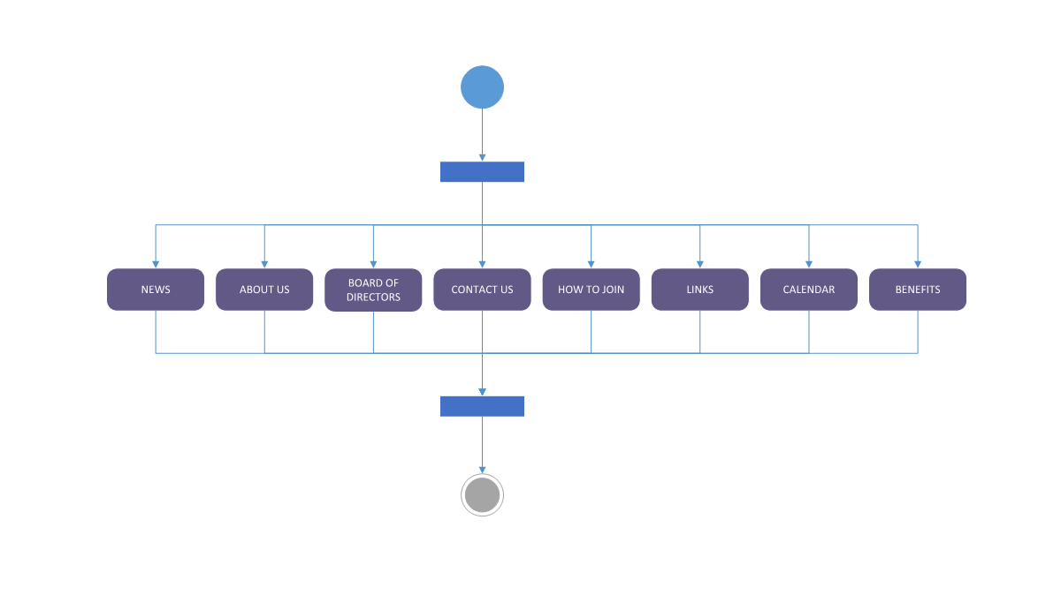

Process Model To-Be

This is the proposed website layout as envisioned by Essential Systems. There are now options to subscribe to an electronic newsletter via e-mail, print out KY HBPA forms, as well as the ability to accept donations as well as all of the links from the as-is model. There would be a register and sign-in page which would allow members to login and manage their membership along with a separate admin sign-in page which would allow a KY HBPA employee the ability to modify the website itself.

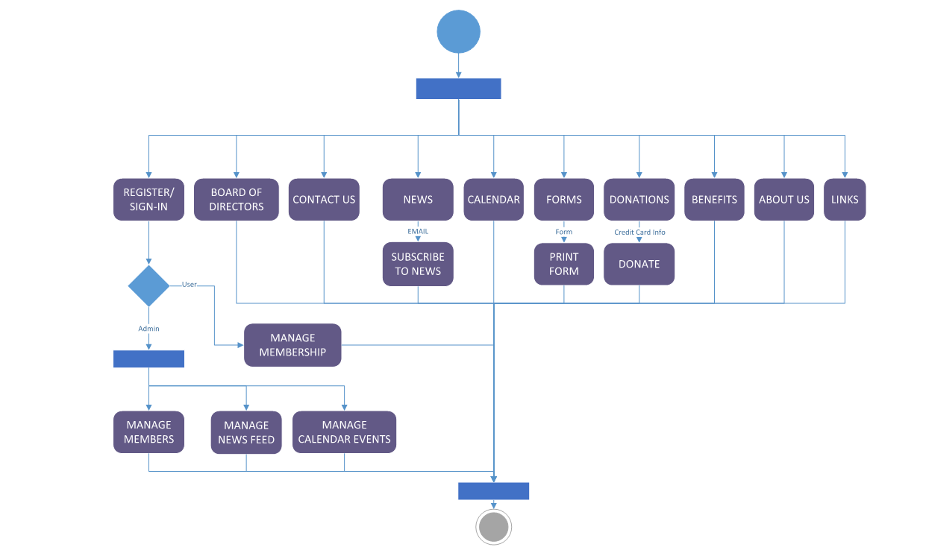

System Requirements

A Race to a New System

These are what will be used to create the system and improve the website. They are written in the "shall" format to provide precise details about what each product will be able to do.

PayPal (Online Payment System)

1. PayPal shall validate the credit/debit card entered.
2. PayPal shall process monetary transactions on the website.

G Suite (Business Email)

1. G Suite shall push emails and newsletters to members instantaneously.
2. G Suite shall remove some paper from the operation.
3. G Suite shall provide a company domain name.

Microsoft Azure (SQL Server)

1. Microsoft Azure shall protect against data loss.
2. Microsoft Azure shall add data continuity.
3. Microsoft Azure shall allow for access of the same files on multiple locations from anywhere in the world.

Use Cases

One of the most important aspects of recovering from a disaster, when it comes to a business, is getting all of your data back. Doing this is easier said than done if there is not some plan in place. If your company is just using a hard copy system or an external hard drive, all of that data could be easily corrupted/ ruined in the event of a natural disaster.

Use Case Name: Backup

Primary Actor: Company

Description: Our ideas for backup will entail saving all data in a cloud storage system so everything they would need is accessible anywhere at any time. This also ensures that if the office was flooded or burned down, then the data is still safe in the cloud and can easily be accessed from non-damaged devices.

If someone has a question or wants to make a comment to the company, it would make it easier on everyone to provide a place on the website to do that. The current website does provide contact information but it is not necessarily the easiest way to accomplish this task.

Use Case Name: Contact Us Via Web

Primary Actors: Members/ Employees

Description: With our new form, members or just general website visitors could easily fill out the form to contact an employee at the KHBPA. This will allow the person doing the act of contacting to have a simple way to make their comment or ask a question, while the person receiving gets this information all in one place rather than having to field phone calls and emails at the same time.

Members need a way to interact with the website and organization so that they can manage their information.

Use Case Name: Login

Primary Actor: Members

Description: Login will allow the page to track members. It will also allow members to manage their profiles and interact with the page across multiple sessions.

KHBPA does not currently receive a whole lot of donations, but an online donation form gives members and the general public an opportunity to give back to the KY HBPA.

Use Case Name: Donations

Primary Actor: Members

Description: A Donations page would enable members and visitors to donate funds to the HBPA online.

Members could have the opportunity to pay for forms and reports electronically saving both them and the KY HBPA time and labor.

Use Case Name: Form Payment

Primary Actor: Members

Description: A Form Payment system would enable members to have forms processed online.

Many of KY HBPA members exclusively access the website through their smartphones at the track. Having a mobile layout for the website ensures that they are able to use the website to its fullest capability.

Use Case Name: Mobile Layout

Primary Actor: Members

Description: A Mobile layout will allow members to visit the page on their mobile devices using a mobile-friendly interface.

Sometimes disaster can strike a business. Flood, fire, or any other natural disaster could hit the building and destroy the computers, files, and safe deposit box. Natural disaster can be detrimental to a business. However, with a recovery plan, a business is able to get back up as quickly as possible and can resume work with little to no down time. That is where Microsoft Azure would come in. If something happened and the business lost all physical files, an employee could get on a laptop that was not affected in the disaster and see the files virtually from there.

Use Case Name: Recovery

Primary Actor: Employees

Description: The recovery option will allow the Kentucky Horseman Benevolent and Protective Association to recover or regain any lost data from the cloud service in case of an emergency. Many companies can have a technical issue and be down anywhere from hours to days. With a recovery option, such as backing information up to the proposed Azure cloud system, the downtime in a state of emergency would be minimal.

People love to see photos. That is why so many websites include a photo gallery. Any member or person with internet access would be able to log into a browser and click the option for the photo gallery. Once the photo gallery loads, the viewer would be able to scroll through and look at all of the available pictures.

Use Case Name: Photo Gallery

Primary Actor: Members

Description: The photo gallery will allow the members and other site visitors to view photos from the track and various races. There will also be some photos submitted by members to the Kentucky Horsemen Benevolent and Protective Association to be uploaded to the site. This will also need some integration from social media photos to the website.

One of the most important things in the Kentucky Horsemen Benevolent and Protective Association are their members. Most importantly the active members. However, there is not a current way of seeing who is registered as an active member for the season. With the database for member logins, there could be an option to see if the member is currently active in the season. An employee would just need to go to the database table and sort by those who are active members to see who are eligible for benefits at the time.

Use Case Name: Manage User

Primary Actor: Company

Description: As of right now, there is not a system for seeing which members are in active status. With a user account database, the Kentucky Horsemen Benevolent and Protective Association will be able to easily see which members have registered for races and those members that are in the Unites States for the season.

The would be updated by the employees but predominantly used by the members. A calendar is the easiest way for members to know deadlines and upcoming events. A member can log into a browser and visit the website to see a calendar on the homepage. The calendar can possibly be set to update along with social media events.

Use Case Name: Calendar

Primary Actor: Members

Description: The calendar will be in place to keep members updated with upcoming events and other important events. The calendar will be updated by an employee and should be able to connect to social media to make sure event details are always kept up to date.

Use Case Name: Email Newsletter

Primary Actor: IT personnel

Description: An email will be typed in and sent to the membership with email addresses. It will also be able to send important information and documents to members

Members could have the ability to fill out and print required KY HBPA forms electronically and then print them out to mail or hand in to the organization.

Use Case Name: Print Forms

Primary Actor: Members

Description: Members will be able to click on the “Print Form” icon, which will bring up their printer options and allow them to print out the document

Members could fill out a form they printed and then resubmit that form electronically to the KY HBPA through the website.

Use Case Name: Scan Documents

Primary Actor: Members

Description: Members will be able to click on the “Upload document” icon, which will bring up their file explorer for them to upload a document with a scanner.

Members could upload an image file to the KY HBPA.

Use Case Name: Upload Image

Primary Actor: Members

Description: Members will be able to click on the “Upload document” icon, which will bring up their file explorer for them to upload a picture taken with a camera

.

For the website to be the most beneficial to the members, it is very important for the KHBPA to know the what the members want to see. It also important to understand how the members feel about different topics within the horse racing industry.

Use case name: Member poll

Primary actor: Members

Description: A question with a certain number of possible answers for the members to choose from. The member selects whatever answer they think is the right one to the question.

It is very important for members to be able to contact the employees of the KHBPA at any time about any important information or issues.

Use case name: Employee info page

Primary actor: Members

Description: Members click on the “Employee Info” tab and it will take them to a page with information of all employees.

One of the processes for the KHBPA is to provide money to those who must have their horse euthanized. For the money to get to the right people they need to submit claims to the KHBPA. Processing claims can be complicated but if done online, can be simplified.

Use case name: Processing claims

Primary actor: Members

Description: The member will go to the “Process claims” tab and will enter all of the appropriate information. They will then click the “Submit claim” button and it will be submitted.

Members of the KHBPA need to be up to date on what is happening around the state and country within the horse racing industry. It is vital that they receive a constant update of news and information throughout the industry. Members of the KHBPA will receive the most up-to-date information with a news feed.

Use case name: News feed

Primary actor: Members

Description: This allows for an automatic, constant update of new information from various websites. This allows the members to stay informed and up-to-date with what is happening around the horse racing industry.

Employees of the KY HBPA run multiple social media accounts to engage with their member base. Social media links give members the ability to interact with the KY HBPA on a deeper level.

Use Case Name: Link to Social Media

Primary Actor: Members

Description: Links to the social media pages for the KY HBPA will be added to the main homepage for Members to click through to KY HBPA social pages.

A social media feed is an excellent way for existing social media accounts ran by KY HBPA employees to get exposure from members visiting their website. Curious members wanting more information can then click on the links to the social media pages for additional information.

Use Case Name: Social Media Feed

Primary Actor: Employees

Description: Highlights from the various social media pages ran by KY HBPA employees will be added to a feed that will be displayed on the main homepage.

Members need a better way to register as a member of the HBPA. One way to do this is to allow members to create online accounts so that they can sign-up and manage their membership in one place

Use Case Name: Sign Up

Primary Actor: Members

Description: Members will be able to complete a sign-up form which will allow them access to manage their membership, fill out forms and request reports from the KY HBPA.

Members need an ability to view their available benefits and fill out forms to use those benefits.

Use Case Name: View Benefits

Primary Actor: Members

Description: Allows members to view benefits available to them and gives them opportunities to fill out requests to use those benefits.

Traceability Matrix

The traceability matrix acts as an overview for the use cases. The traceability matrix shows the technical assumptions and customer needs for the use cases. Within the traceability matrix, any related requirements are shown as associated with the ID being shown in the second column. Every requirement is shown with technical assumptions and architectural designs as well.

|  |  |  |  |  |  |  |  |  |  |  |  |  |
| --- | --- | --- | --- | --- | --- | --- | --- | --- | --- | --- | --- | --- |
| **REQUIREMENTS TRACEABILITY MATRIX** | |  |  |  | | | | |  | |  |  |
| **Project Name** | The Race to a New System |  |  |  |  |  |  |
| **Project Type** | ***Technical Organization*** |  |  |  |  |  |  |
| **Project Start Date** | 15-02-17 |  |  |  |  |  |  |
| **Project End Date** | 02-05-17 |  |  |  |  |  |  |
| **Project Sponsor** | Essential Systems |  |  |  |  |  |  |
| **Primary Driver** | ***Andrew Huff*** |  |  |  |  |  |  |
| **Secondary Driver** | Louis Ries |  |  |  |  |  |  |
| **Division** | Technology |  |  |  |  |  |  |
| **Project Manager/Department** | Robert Barker |  | | | | | | | | | | | | | | | | |
| ***ID*** | ***Assoc ID*** | ***Technical Assumption(s) and/or Customer Need(s)*** | ***Functional Requirement*** | ***Status*** | ***Architectural/Design Document*** | ***Technical Specification*** | ***System Component(s)*** |
| 001 | 007 | Payments can be made online. People need to order forms without having to travel to Louisville. | Process online payments | In Progress | User goes to the webpage and clicks to a document and enter their credit card information into the page. | A website will just need to embed the PayPal payment button. | PayPal linked button |
| 002 |  | Newsletter and easier communication to members | The business email will be used to send newsletters. | In Progress | Employee logs into new domain email to create and send emails or newsletters to members. | A newsletter signup and new domain will need to be created. | G- Suite |
| 003 |  | A way to backup data will be needed. | Microsoft Azure will backup data. | In Progress | Database for the company and storage unit for important documents that are being stored in filing cabinets right now. | A Microsoft Azure account and setup will be required. | Microsoft Azure database and storage linked to website and domain email. |
| 004 | 003 | A recovery method is needed. | Microsoft Azure will hold data to be recovered. | In Progress | The data from the backups will just be opened to recovery files. | A Microsoft Azure account and setup will be required. | Microsoft Azure database and storage linked to website and domain email. |
| 005 |  | There needs to be a contact us page on the website. | Information is displayed for members to contact the company. | In Progress | The website will be programmed to show a contact us page. | The website will need to be formatted with a contact us page. | The website. |
| 006 | | 014 | There needs to be an online login for members. | The members need to be able to use a unique I.D to login to the website. | In Progress | The website will have a login area that transfers data to a database. | The website will need to be connected to the database to pull the information when members log in. | Microsoft Azure database. | Microsoft Azure | |  | | | |  |  |  |  |
| 007 | | 001 | There needs to be an online donations page. | Members and other site visitors will be able to donate through the website. | In Progress | A user can go to the website and click the donate button to enter their credit card information into the page. | A PayPal donation button will be linked. | PayPal linked button | PayPal | |  | | | |  |  |  |  |
| 008 | |  | Members need to access the site via mobile devices. | Members will be able to view the website on their mobile device. | In Progress | The site will have a mobile compatibility. | The website will need to be formatted to a mobile compatibility. | The website. | Website | |  | | | |  |  |  |  |
| 009 | | 010 | Members need a way to print forms. | Members need to be able to print forms from the website. | In Progress | Printable forms or a pdf file will need to be available on a page. | The website will need to include printable forms. | The website. | Website | |  | | | |  |  |  |  |
| 010 | | 009 | Members need a way to scan documents. | Members need to be able to scan documents into their profile for situations like claims. | In Progress | There will need to be an option to upload documents into the website. | The website will need an uploads page. | The website. | Website | |  | | | |  |  |  |  |
| 011 | | 016 | Members need a way to upload photos. | Members need to be able to upload images from races or a member profile picture. | In Progress | There will need to be an option to upload photos into the website. | The website will need an uploads page. | The website. | Website | |  | | | |  |  |  |  |
| 012 | |  | The website needs links to social media. | Social media platforms need to be linked to the website for easier access. | In Progress | There will need to be social media links embedded. | The website will need a social media link embedded. | The website. | Website | |  | | | |  |  |  |  |
| 013 | | 012 | The website needs to push content from social media. | Social media feed need to be pushed to the website to keep content up to date. | In Progress | The links to social media need to show on the site. | The website will need a link to social media. | The website. | Website | |  | | | |  |  |  |  |
| 014 | |  | Members need an online sign up method. | Members need a way to sign up online. | In Progress | The website will need to take information entered and transfer it to a database. | The members will sing up and the information will be added to the database. | Microsoft Azure database. | Microsoft Azure | |  | | | |  |  |  |  |
| 015 | | 006 | Members need to view benefits. | Members need a way to view their current benefits. | In Progress | The website will need a page for benefits. | The website profiles will need a benefits page. | The website. | Website | |  | | | |  |  |  |  |
| 016 | |  | A photo gallery should be added to show members race photos and photos from other events. | Members need a way to view photos from races or other events. | In Progress | The website will need a place for photos to be gathered in a gallery. | The website will need photos to be enabled. | The website. | Website | |  | | | |  |  |  |  |
| 017 | | 006 | There needs to be a way to manage users. | The Kentucky Horsemen's Benevolent and Protective Association needs a way to manage current members and a way to manager online users. | In Progress | The database will need to see if the member has any active data for the season to decide if they are an active member. | The database will need to show which members are active. | Microsoft Azure database. | Microsoft Azure | |  | | | |  |  |  |  |
| 018 | | 022 | Upcoming events and important deadlines will need to be added in the calendar for members to see. | The Kentucky Horsemen's Benevolent and Protective Association need a way to keep content up to date and inform members of upcoming events. | In Progress | The website will need to be easily updated, and have an embedded link to transfer data from social media to the site. | The website will need the calendar to be easily updated. | The website. | Website | |  | | | |  |  |  |  |
| 019 | |  | There needs to be a way to poll members. | Important questions will be able to be asked if members can be polled. | In Progress | Employees can make polls on a third party website and post the link to the website. | An account with a third party polling system would be needed. | Third party website | Third party website. | |  | | | |  |  |  |  |
| 020 | | 005 | There needs to be an employee information page. | Employee information needs to be added to the page for members to contact them | In Progress | Employee information can be programmed into a separate page. | The website will need to be programmed. | The website. | Website | |  | | | |  |  |  |  |
| 021 | | 010 | There needs to be a way to process claims. | An online claims process needs to be added for member convenience. | In Progress | The website will need a way to process claims but also be HIPPA compliant. | The website will need to be programmed. | The website. | Website | |  | | | |  |  |  |  |
| 022 | | 013 | There needs to be a way to update news. | The members need to be informed of current issues that are too important to wait until a newsletter or calendar update. | In Progress | A way to update news quickly will need to be programmed into the website. | The website will need to be programmed. | The website. | Website | |  | | | |  |  |  |  |

The KHBPA cannot process online payments for donations or forms that a member requests.

The KHBPA cannot send an online newsletter to members and as a result has to pay for printing.

The KHBPA has no form or business continuity or disaster recovery.

Cloud Database

Newsletter

Online Payment System

Microsoft Azure

G Suite

PayPal

Initial Architecture Considerations

For our initial architecture considerations, we propose using a combination of Microsoft Azure and GSuite as the backend of the system. Please refer to figure 1 for more information.

Microsoft Azure - Basic – 5 DTUs Max storage 2GB price $5.00/mo

Amazon Web Services - db.t2.micro - $294.00/3 yrs with $131/yr remaining

SaaS – Office Software

GSuite - $100/mo for business plan (w/ e-mail)

Office 365 - $82.50/mo for business plan ( no e-mail)

Carbonite – 269.99/yr 250gb storage

Elephant drive – 9.95/mo 1tb storage

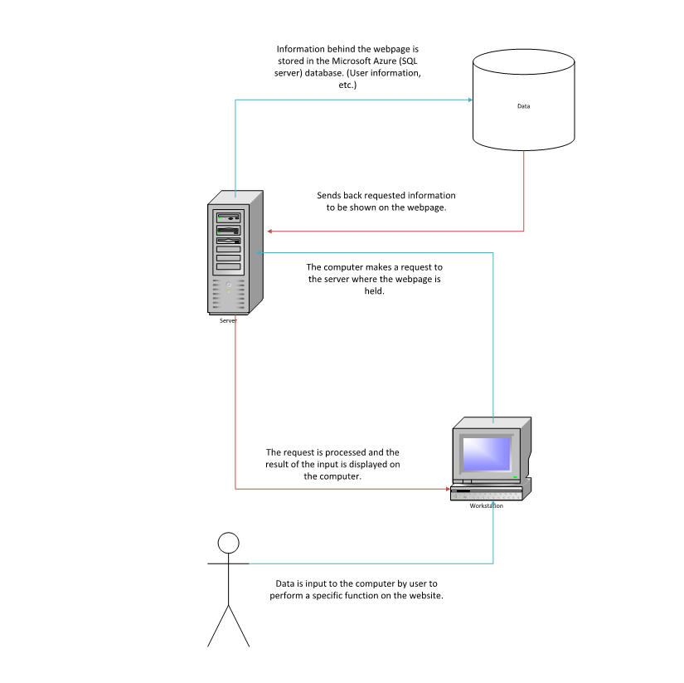

Figure 1: Proposed User Interaction with System

Risk Analysis

The risk analysis dissects the criteria in which risk is measured for each process of the website. This page will also show the level of security importance of each process.

Use Cases

**Criteria:** For the use cases, we will define risk as the possibility of unauthorized access to a specified area of the website.

1. The first use case is an online payment system that allows the processing of online payments through a credit/debit card. This system will also allow monetary donations to the organization.
   1. **Risk level:** High. If someone gets into this they will be able to get the card numbers of anyone who has paid through the website.
2. The second use case is a business email where we send out a newsletter to all members. This will also allow the KHBPA to have their own domain.
   1. **Risk level:** Low. If someone gets to this they will be able to see all emails sent through the organization. They could also send out erroneous emails to all of the members.
3. The third use case is a cloud-based database that contains information on all current members. This will centralize of the information into one, easy to access spot.
   1. **Risk level:** Very high. If someone gets into the database then the organization will be in a very tough spot because that unauthorized person now has information on every member in the organization. This might include address, credit card number, and other confidential information.

Other risk areas

1. Calendar/newsletter
   1. **Risk criteria:** The possibility that erroneous information is posted on either the newsletter or the calendar.
      1. **Risk level**: Low. If someone posts bad information then it is possible that the members will not be up to date on important information.

During the elaboration phase, we will address these areas of risk through several different ways. The most important area of risk that we need to address is the possibility of unauthorized access of the database. We will address this by giving certain people only certain amounts of access to the database. The admin will have full control while others may only be able to view the data. This people will be carefully monitored and chosen. This will also be how we make sure the correct information is posted in the newsletter and calendar.

Essential Systems Team Charter

For our team, the Essential Systems group, our main objective for this project is to ensure that KHBPA has a fully functioning website, one that meets all of their requirements and fixes some of their current problems. We would also like to get an ‘A’ on this project but that is not as important to us. Achieving these goals is only going to happen if we work together as a team. This means that we all have to be on the same page. Everyone needs to have a clear idea of what their work is and when it needs to be done. We need to clearly communicate our ideas or any concerns we have with this project. Everyone’s voice needs to be heard on all topics. When decisions are going to be made, everyone will have the opportunity to express what they will believe is the best choice for the group going forward. Ultimately our goal is to get the website functioning like what the KHBPA wishes and following this formula will help us reach that goal. Ultimately our goal is to get the website functioning like what the KHBPA wishes and following this formula will help us reach that goal.

The first step in reaching our ultimate goals, is to arrange group meetings to discuss the direction that we should take the project. These meetings will become the cornerstone for everything that we will do. In these meetings, will discuss the work that we have completed, the work we are currently working on, and the work that needs to be done. The meetings will allow us to peer review each other’s work to make sure everything is in line with the instructions, and provide feedback on what we think was good and parts that may need some work. The meetings are also where we will be able to make sure when everybody knows when the next assignment is due. Meetings will usually be arranged at the end of the current meeting. This will give us time one-on-one to discuss everyone’s schedule and what times work the best for everyone. If we can find a time where everyone is free, then that will be the time of the next meeting. If we can’t find a time for everyone, then we are forced to find a time that is good for most of the group. Those who miss a meeting will be filled in through text message or at the next meeting. Everything in these meetings will be documented on OneDrive so that members can access the info at any time.

As mentioned in the first paragraph, clear communication will be the most important aspect of this project. For our group, trying to schedule a meeting can be tough since we all have jobs and other obligations. So, our main form of communication is through text message. We use the app GroupMe, which allows group messaging between all types of phones, to send messages since not everyone has the same type of phone. Another form of communication that is very useful for us is through OneDrive. This allows a member to create a document and share it with the rest of the members at any time. This is very important for us because it allows compatibility between members without actually being in the same room as each other. All of the work that we are working on and complete will be saved on the OneDrive. Another important form of communication for us is Skype. Skype allows us to talk to each other and see each other like we were in the same room, but it is actually over the internet. This allows us to pretty much have a meeting whenever we want. In terms of communicating with the client and the professor, e-mail will be what we will be using.

As with any group project, there will be many decisions that will have to be made. With these decisions will come differing opinions from each of the group members on how what decision is best for the group. The process that we take to solve a problem, make a decision, or resolve a conflict will be pretty much the same: the majority rules. First, we will make sure that all options are on the table. Next, we will vote on what we think is the best option. We will continue to do this until we have come up with a final decision or there are no more decisions to make. I think the important part of this is making sure that everyone’s voice is heard and that we have plenty of options before we start the process.

To make sure that everything that we do during and outside of the meetings is kept track of, we will put all documents onto the OneDrive. On this OneDrive we will have all of our completed work, as well as our unfinished work. We will also have notes of ours that we have shared between each other.

The Gantt chart is updated for iterations two and three. It shows when we as a team should have tasks completed by and who is responsible for getting the tasks complete. The list of use cases, system requirements, vision document, architectural considerations, risk analysis and a few prototypes were completed for the last iteration. Now we are finalizing the use cases, making diagrams, and constructing prototypes for the use cases.

Gantt Chart

This is our proposed timeline for this project.

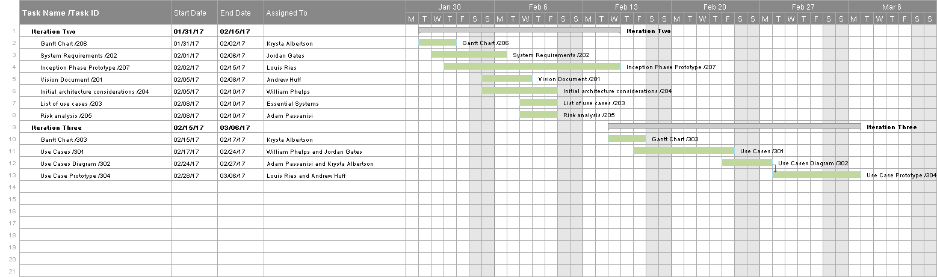

Home Page

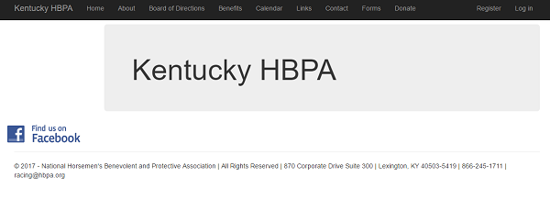

This screen shows the layout of the website as a prototype.

Donations Page

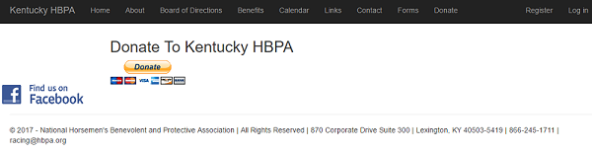

The donations screen prototype shows a button linking to a 3rd party site, such as Paypal, for handling online payments such as donations.

Registration Page

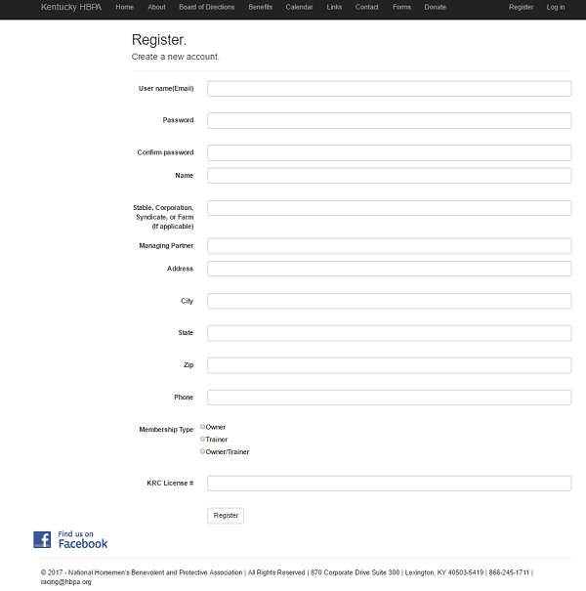

The registration page prototype shows the inputs for registering as a new member.

Mobile Home Page

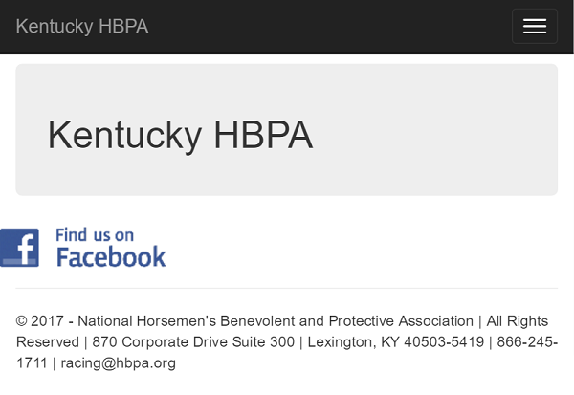

This screen shows the layout of the web prototype for mobile users. Note that the menu buttons at the top as displayed on the desktop page have been moved to the drop down menu at the top right corner.

Mobile Menu

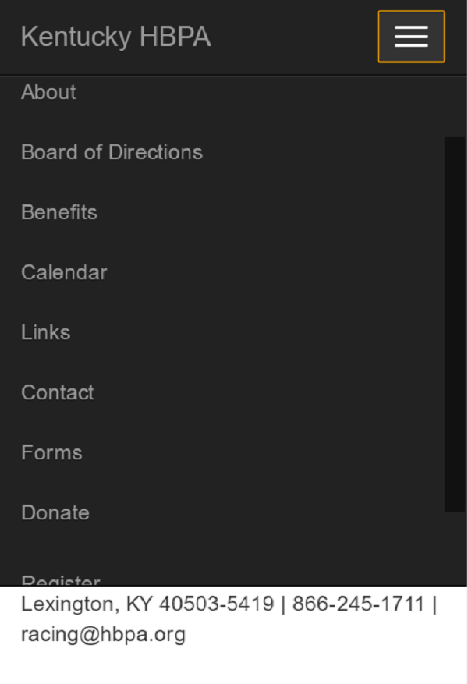

This screen shows the prototype for the mobile menu and its scrollable interface.

Mobile Registration Page

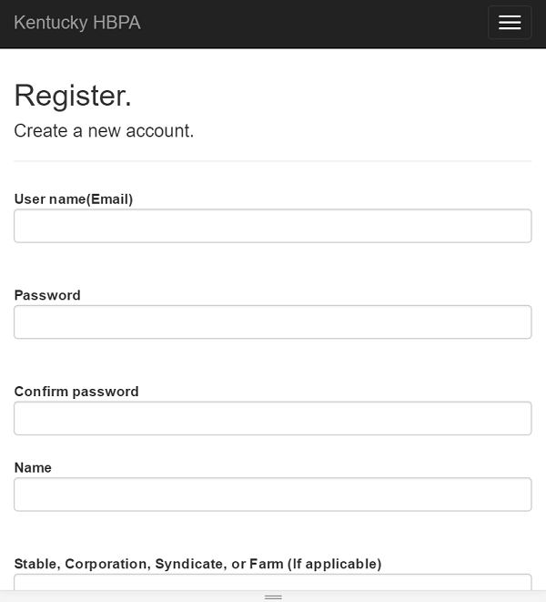

This screen shows the registration page as it might appear on a mobile device.